研習報告與討論

Qualitative analysis of ntl7

姓名：陳泓志
學號：u901673
研習地點：中研院分生所N317
指導教授：蔡宜芳博士

Summer Research(2003/7~8)

~ in Institute of Molecular Biology Academic Sinica R.O.C^{[1]}

Dr. Yi-Fang Tsay ^{[2]}, 陳泓志(u901673)
Qualitative analysis of ntl7

Qualitative analysis of ntl7
Abstract:
ntl7 is one member of nitrate transport gene family. It is also a homologous gene of chl1^{[3]}, which is the first nitrate transport gene found in Arabidopsis. It is now known that CHL1 has both high affinity and low affinity properties for nitrate transport^{[4]}, and the switch between high affinity and low affinity depends on the phosphorylation of CHL1. We try to figure out where NTL7 is present by Gus-staining. Also we perform Xenopus oocyte functional test to determine the function of NTL7.

Background：
Nitrate is the major nitrogen source of most plant. Therefore it is important for the plant to have efficient transport of nitrate in order to grow better. After absorbing by plant, nitrate can either be metabolized in root directly or be stored in vacuoles for future utilization. It can also be transported to leave and is metabolized there.
For previous found nitrate transport protein, CHL1, it has both high affinity and low affinity for nitrate by modulation of phosphorylation. During phosphorylated, CHL1 is a high-affinity nitrate transport; while dephosphorylated, it becomes a low-affinity nitrate transport. CHL1 has 52 homologous proteins and among them the NTL7. We try to determine the function of NTL7 and the effect it has on plant growth.
For understanding the function of these NTL proteins, scientists can get better idea in the application to agriculture. This may reduce the use of excess amount of farm chemical in cultivation.

Material and Methods：
Production of mutant：
We apply Agrobacterium that carry Ti-plasmid with gene coded for kanamycin resistance protein to infect Arobidopsis.

Mutant screening：
We grow the plant on medium containing kanamycin to select the mutant.
Besides we use Kan-probe to perform Southern blotting in order check the copy number of T-DNA inserting into the Arobidopsis gene.
Result: see supplement
Gus-staining：
Fuse GUS gene at the end of ntl7 gene whose fusion protein has the E. coli glucuronidase activity. Glucuronidase can act on X-Gluc whose products then undergo oxidative dimmerization to form insoluble and highly colored dye.
Solution:(for 5ml)
50 mM NaH₂PO₄ (PH=7.0) (stock=1M) 0.25ml
10 mM Na₂EDTA (PH=7.0) (stock=0.5M) 0.1ml
1 mM X-Gluc (storedin-20℃) (stock=20mM) 0.25ml
0.5 mM K⁺-ferricyanide (stock=5mM) 0.5ml
0.5 mM K⁺-ferrocyonide (stock=5mM) 0.5ml
dH₂0 :3.4ml
- 01%Triton
*Must prevent the solution from exposing to light.
Xenopus oocyte functional test：
For peptide transport test:
<Solution1:>
dileucine(1/800×20μM H³-dileucine+ 20μM dileucine)
220 mM mannitol
0.3 mM CaCl₂
Tris/MES(adjust PH to 5.5)

<Wash solution:>
20μM dileucine
220 mM mannitol
0.3 mM CaCl₂
Tris/MES(adjust PH to 7.4)

Pick 5 oocytes per well

Incubate in 50μl of solution1
(shake with 40rpm)
3hr

remove solution1, and wash 3 times with 300μl of washing solution

remove washing solution and add 100μl of ddH₂O

Pipet oocytes up and down to break them

Remove the lysate into white plastic bottle

For nitrate transport:(HPLC)
96-well plate
Low affinity:
Pick 5 oocytes per well

Drop off original ND-96 (Ca²⁺)

Add 400λ(or 350λ) 10mM nitrate buffer

Stay for 1.5~2.0 hr

Use ND-96 (Ca²⁺) buffer to wash oocytes 5 times

Add 200λ ddH₂O

Pipet oocytes up and down to break them

Detect nitrate conc. by HPLC

High affinity:
Pick 5 oocytes per well

Drop off original ND-96 (Ca²⁺)

Wash oocytes once with 400λ(or 300λ) 150μM nitrate buffer

Add 200λ150μM nitrate buffer, then withdraw 100λof the buffer
into a new well

Stay for 1.5~2.0 hr

Transfer the buffer into new eppendorfs

Detect nitrate conc. by HPLC
We use waterman column for nitrate transport test.

Result：
Through the result of the Gus-staining, it is clear that NTL7 is represented mostly in leaves and lateral roots although some plants seem to have no NTL7 presented in it. (Figure 1.a) (Figure 1.b)
(a)
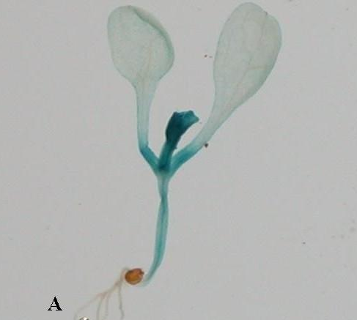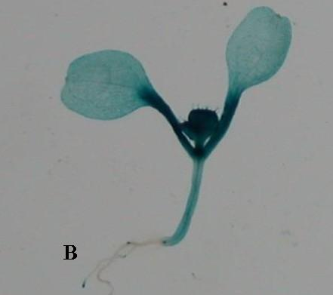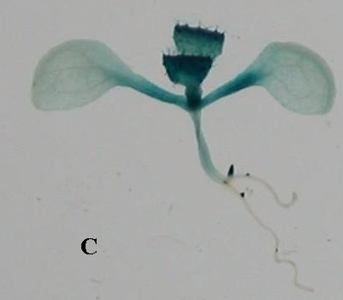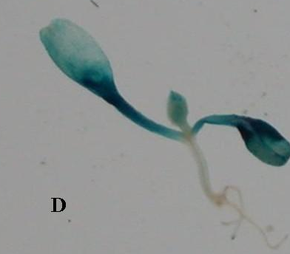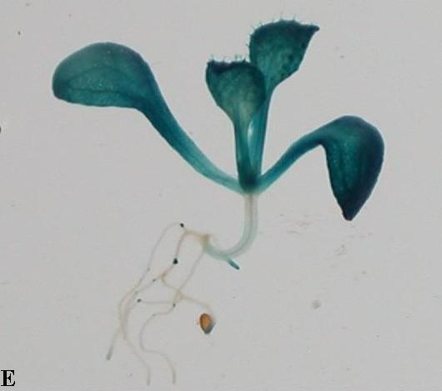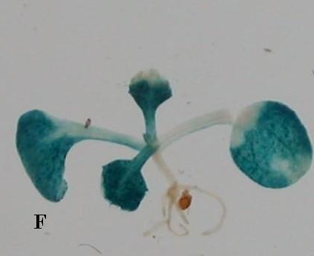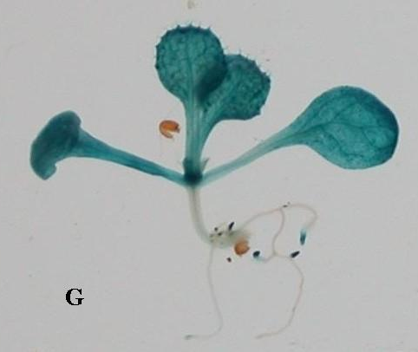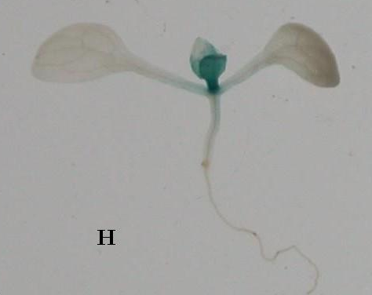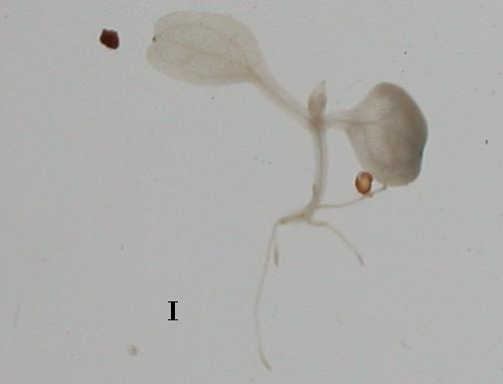

(b)
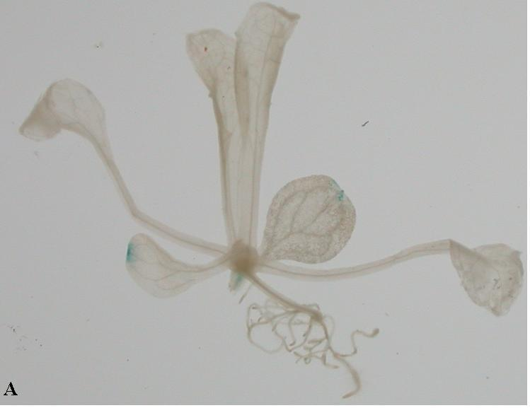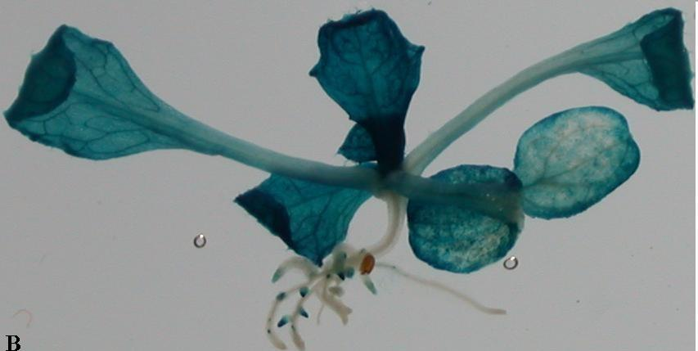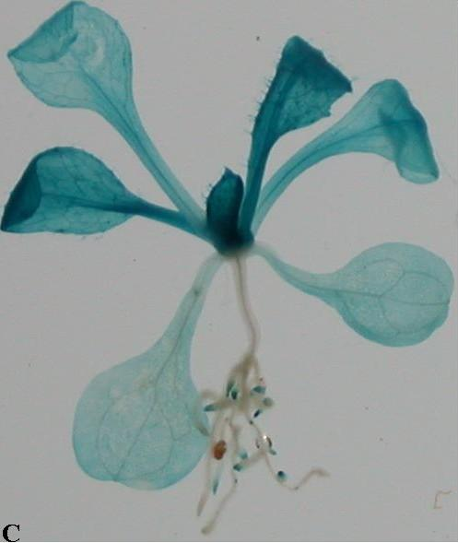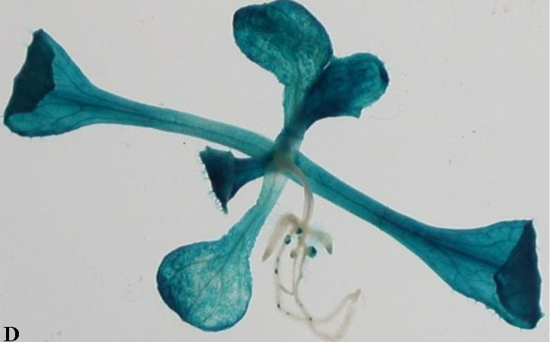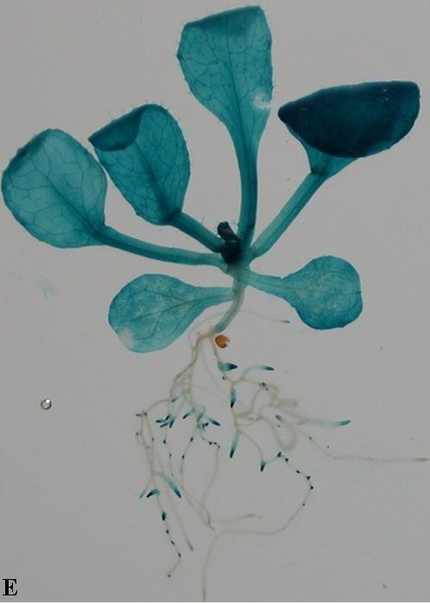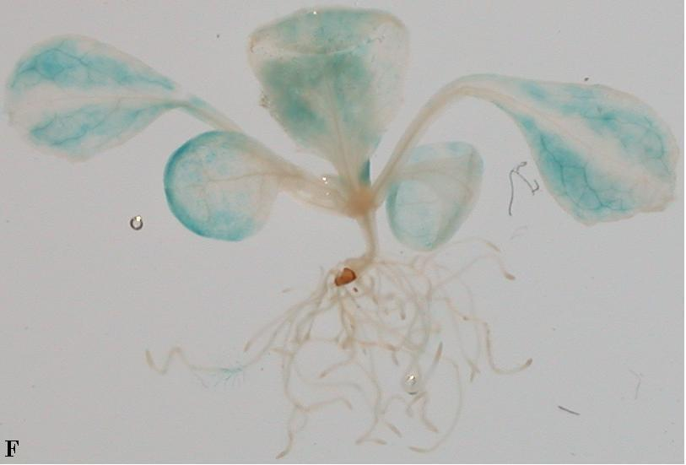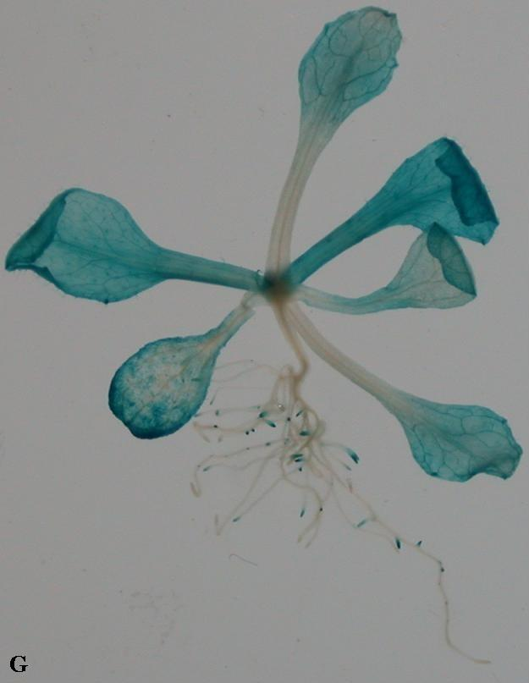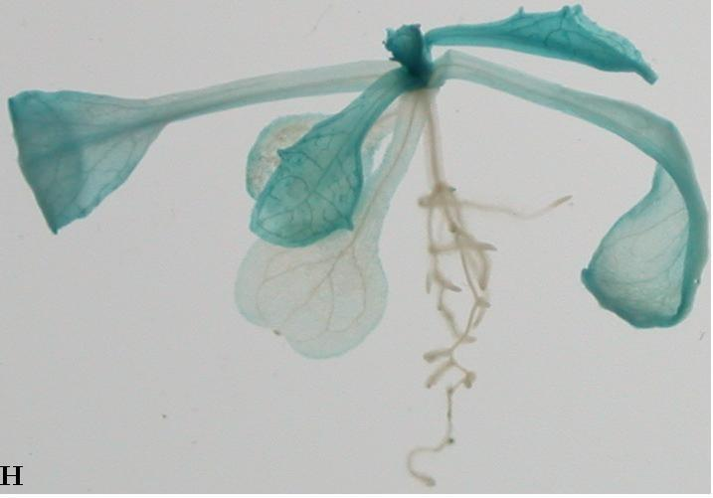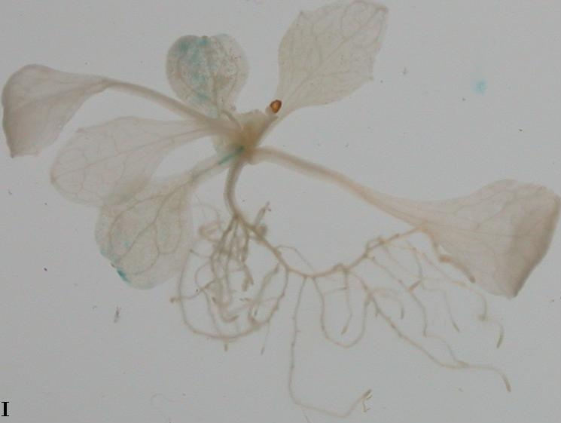
Figure 1:(a) Expression of Gus-staining grows in Ms+Kan plate for 7 days: in A, B, C, D, E, F, and G, NTL7 is expressed almost in the entire plant but primary root; in H NTL7 is expressed only in the new leaves; in I has no NTL7 presented in it.
(b) Expression of Gus-staining grows in Ms+Kan plate for 12 days: in B, C, D, E, G, and H, NTL7 is expressed almost throughout the whole plant but primary root; in A and I, there is no NTL7 expressed; in F, NTL7 is expressed only in the edge of the leaves.

The Gus-staining results for flowers show that NTL7 also exists in flowers, especially in the calyxes and anthers. For the result of Gus-staining of pods, it seems that there exists no NTL7 there. (Figure 2.a) (Figure 2.b) In order to get more detailed information about the location where NTL7 is expressed, the Gus-stained flowers were to be cross-sectioned. It is calyx and anthers that are stained, that is, NTL7 presents here. (Figure 3.)

(a)
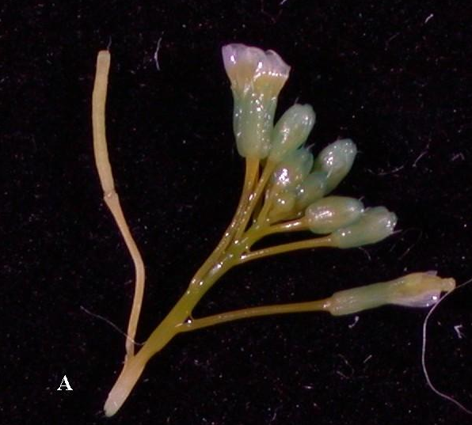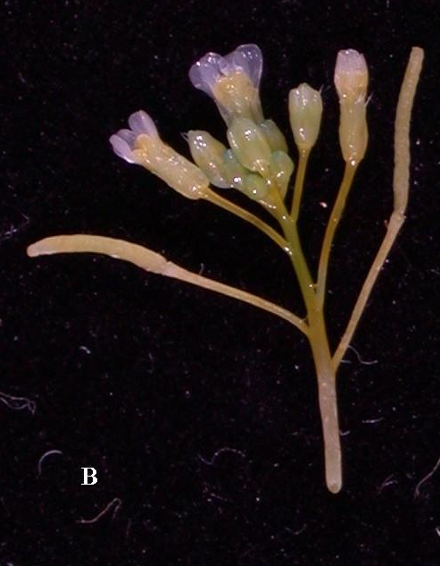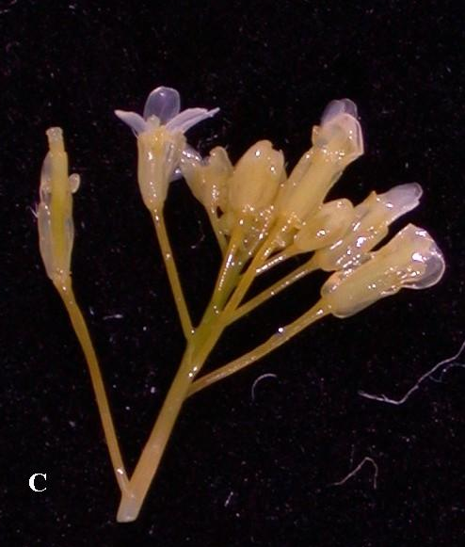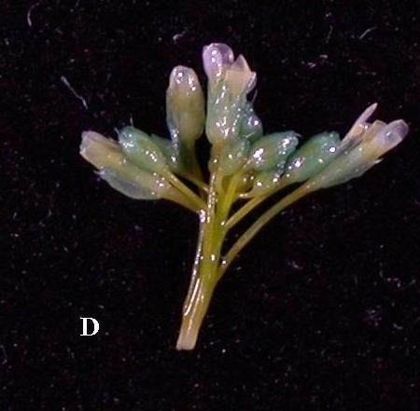
(b)
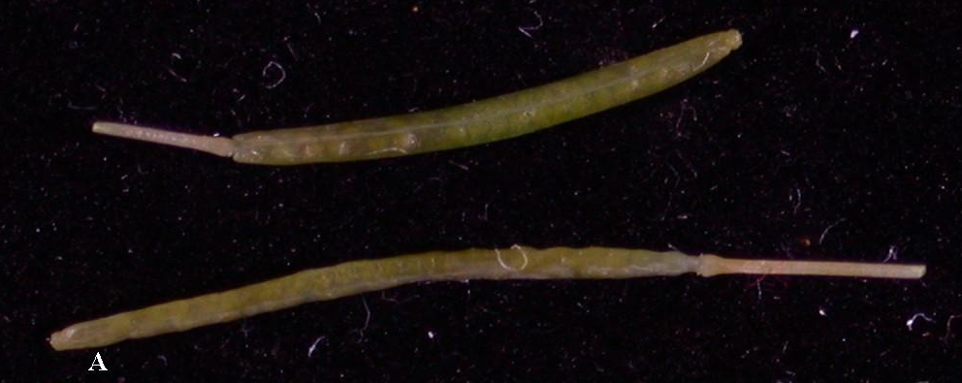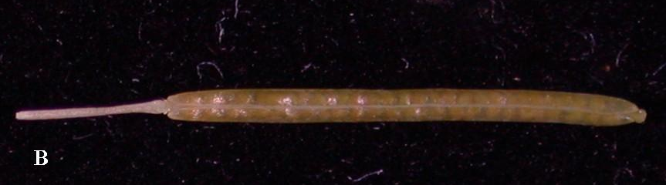
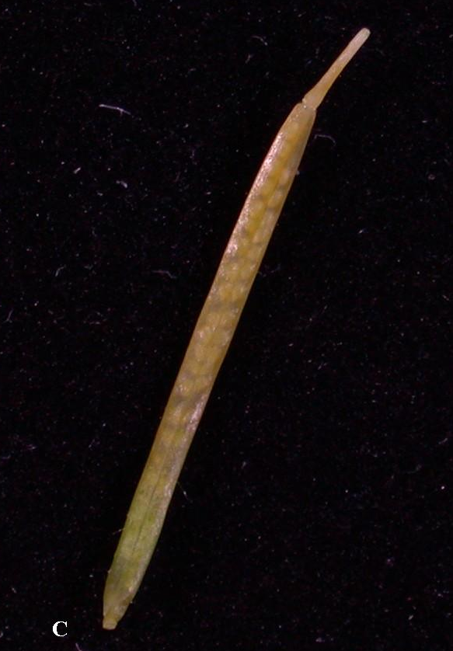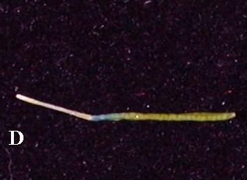
Figure 2:(a) Gus-staining of flower: mostly in calyxes;(b) Gus-staining of pods: it seems that there is no expression.

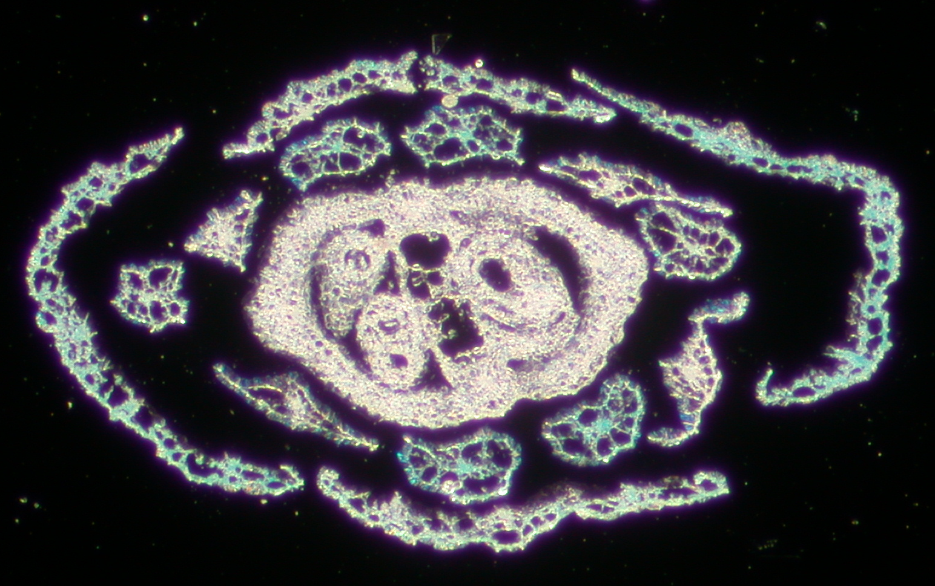
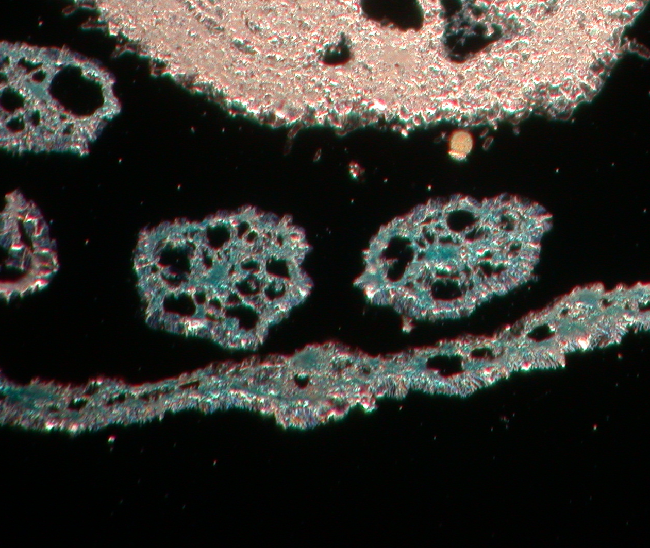

Figure 3: the cross sectioning of Gus-stained flower: NTL7 appears to be in the calyxes and anthers.

For sure that NTL7 is indeed expressed in the membrane, that is, it is a membrane protein, the GFP::NTL7 construct is used to check the position by confocal microscopy.(Figure 4) It is because that ntl7 is one of the homologous genes of chl1 whose protein product is a membrane protein that plays a role in nitrate transport. The result shows, as expected, it is clear that NTL7 is expressed in the membrane.
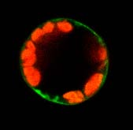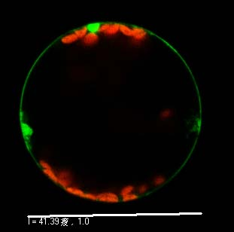
Figure 4 The GFP::NTL7 expression in the cell of the root. The red fluorescence reveals the chloroplast while the green one shows the position of NTL7 in the cell. NTL7 is expressed in membrane.

Functional test of both NTL7 and NTL4
The next step, we tried to find out the function of the protein, NTL7, and NTL4, and therefore we performed the Xenopus oocyte functional test. The former studies showed that NTL4 seems to have the ability to transport peptide, but the result was not certain. For more certainty, we tested the ability for the proteins to uptake peptide first. The outcome tells that NTL4 seems to be incapable of the transport of nitrate. (Figure 5) Besides, we performed the test for nitrate uptake of NTL4. Since NTL4 is the homologous of CHL1, which has a dual affinity for nitrate, both high and low affinity, we tested both affinities for NTL4. The results of the tests are that NTL4 likely has no uptake of nitrate in both low and high conditions, but as for the ablility for low-affinity nitrate uptake, there exists some uncertainty. (Figure 6 a, b)
Figure 5 The peptide uptake assay of NTL7 and NTL4.
The solution contains 1/800×20 μM H3-labeled dileucine+ 20 μM dileucine.
Both NTL7 and NTL4 reveal no peptide uptake.

(a)
(b)
Figure 6 The nitrate uptake assay of NTL4.
(a) The low affinity nitrate uptake assay. The solution used is 10 mM nitrate buffer.
There seems no uptake.
(b) The high affinity nitrate uptake assay. The solution contains 150μM KNO3.
There seems no nitrate uptake.
Discussion：
As we can see from the results of Gus-staining, although some strains have no expression, most strains have the whole plant expressed but their primary root. Also for the flowers and the pods, NTL7 is expressed almost in the calyxes and anthers. There is one thing noticeable that in the same strain but different days for plant growth the NTL7 expressions differ. In other words, there seems to exist some kind of stage-dependent pattern for the expression of NTL7.
The oocyte functional assay showed that NTL4 seems to have no peptide and nitrate uptake ability, however one case in the low-affinity nitrate uptake assay has the result 1.36 nmole nitrate uptake / oocyte. This result is just the same amount as the outcome of low-affinity nitrate uptake test for CHL1. This means NTL4 may have low-affinity nitrate transport, and the no-uptake is probably due to the poor expression of injected RNA or that the injected amount of RNA is not enough.

Reference：
¹ 中研院分生所

² Dr. Yi-Fang Tsay 蔡宜芳博士
1983 B.S. Dept. Botany, Natl. Taiwan Univ.
1985 M.S. Dept. Botany, Natl. Taiwan Univ.
1990 Ph.D. Dept. Biol. Sci., Carnegie Mellon Univ. , USA
1990-93 PDF Dept. Biology, Univ. California-San Diego,USA
2/94-5/99 Assistant Research Fellow, IMB
5/99-目前 Associate Research Fellow, IMB

3. Tsay, Y.-F., Schroeder, J. I., Feldmann, K. A., and Crawford, N. M. (1993) The herbicide sensitivity gene CHL1 of Arabidopsis encodes a nitrate-inducible nitrate transporter. Cell 72, 705-713.

4. Liu, K.-H., Huang, C.-Y. and Tsay, Y.-F. (1999) CHL1 is a dual-affinity nitrate transporter of Arabidopsis involving in multiple phases of nitrate uptake. Plant Cell 11, 865-874
Acknowledgement：
Dr. Yi-Fang Tsay et al.

Supplement：

The result of Southern blotting for screening
(A)
This one is hybridized with newly-made Kan probe
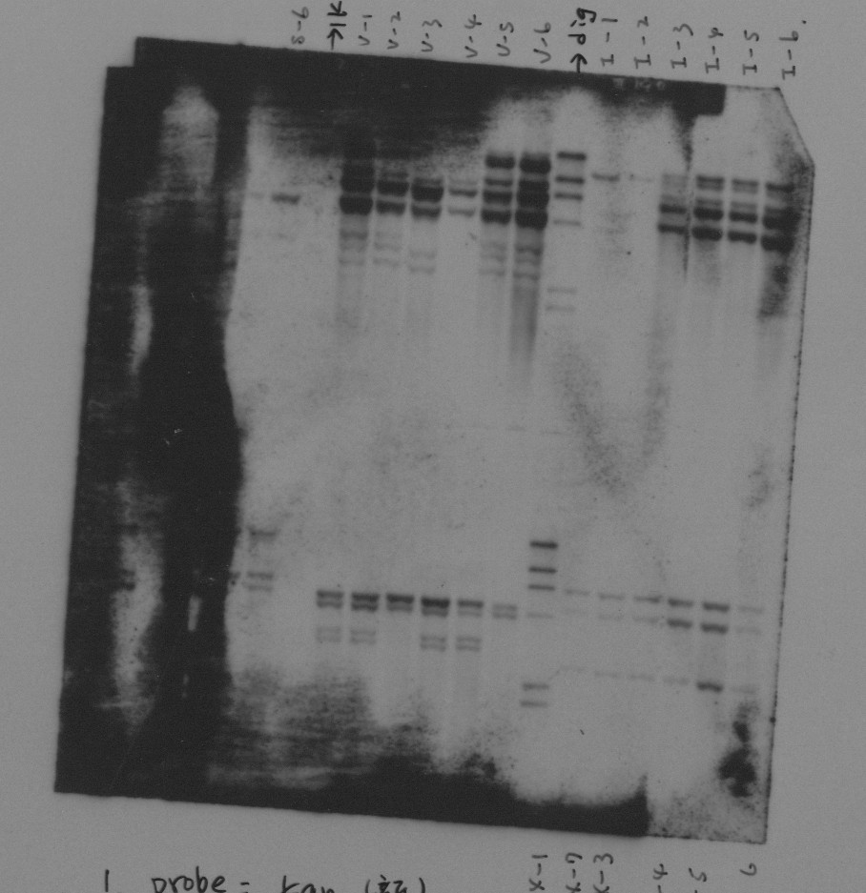
Copy number of T-DNA
S: 1
V: 3, 5, 7
Ι: 1 or 5
Ⅱ: 3
Ⅴ: 2 or 4
Ⅹ: 3

(B)
This one is hybridized with old Kan probe.
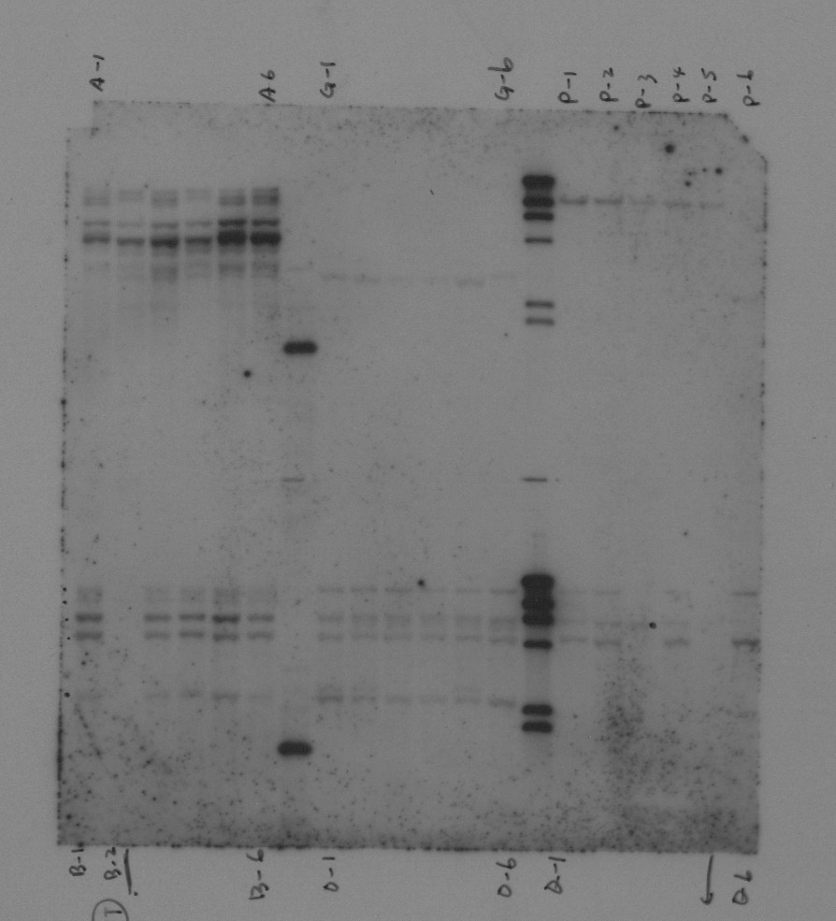
Copy number of T-DNA
A: 4~7
B: 0 or 5
G: 1
O: 4
P: 1
Q: 0, 1, 3

(C)
The lines from the let are: 1E-3, 1E-2, 1E-1, 1D-3, 1D-2, 1D-1, DIG marker,
3G-6, 3G-5, 3G-4, 3G-3, 3G-2, 3G-1, 1Kb marker, 4K-6, 4K-5, 4K-4, 4K-3, 4K-2, 4K-1.
Copy number of T-DNA
1E: 1
1D-3: 0
1D-2: 4
1D-1: 3
3G: 4
4K-3, 6: 1
4K-1, 2: 2
4K-4, 5: 3

