The Subcellular Localization of Steroidogenic Factor -1
Fu Huang
Department of Life Science, National Tsing Hua University, Taiwan

ABSTRACT
Steroidogenic factor-1 (SF-1) is a key regulator of endocrine development and an orphan nuclear receptor that was always found in the nucleus. Using transfection of SF-1 into mouse adrenal cells and confocal laser microscopy, I demonstrated that SF-1 also distributes in cytoplasm. The location of cytoplasmic SF-1 and the mechanism of its export from nucleus have not been determined yet. But homology analysis suggests that the ligand-binding domain of SF-1 may contain an LMB-independent NES sequence. By cotransfection of SUMO-1 and SF-1 into mouse adrenal cell, I found that sumoylation, one of the posttranslational modifications of SF-1, could regulate the nuclear distribution of SF-1.

INTRODUCTION
Steroidogenic factor-1 (SF-1), a transcription factor known to be significant in steroidogenesis, sex differentiation and adrenal development, is an orphan nuclear receptor that is expressed in the adrenal gland, gonads, spleen, ventromedial hypothalamus and pituitary gonadotroph cells (1). It has been reported that the Ftz-F1 box of SF-1 contains NLS sequence (2), and SF-1 was always found in nucleus in previous study. Abundance and activity of SF-1 can be regulated by posttranslational modifications, including phosphorylation and acetylation. Recently, two sites in SF-1, K-119 and K-195, have been found for covalent modification with the ubiquitin- related protein SUMO-1. SUMO-1 resembles ubiquitin both in structure and in the mechanism of attachment, and is reversibly attached to a large number of proteins. Molecular consequences of this dynamic modification vary between targets and include alterations in protein/protein or protein/DNA interactions, changes in localization, enzymatic activity, or stability (3).
SUMO-1 can trigger the formation of PML nuclear bodies and form speckles in nucleus. The role of sumoylation in modulating SF-1 transcriptional activity is not known yet, but previous study suggests that sumoylation may affect the nuclear distribution of SF-1.

MATERIALS AND METHODS
Cloning of pFLAG-DsRed-SUMO1
Our DsRed2 clone was amplified by PCR to generate a fragment containing a HindIII site at the 5’ end and a KpnI site at the 3’ end. This fragment was generated using the upstream primer: 5’ GAT GAC GAC AAG CTT ATG GCC TCC TCC GAG AAC 3’ and the downstream primer: 5’ GCG GTG GTG GAC AAG GAC AGC CAT GGT CAG 3’. After digestion with HindIII and KpnI the 723bp fragment was ligated to the original plasmid pFLAG-SUMO1 WT (wild type) and pFLAG-SUMO1 AA (mutant, the Gly-96 and Gly-97 were changed to Ala) digested with HindIII and KpnI, which cuts in the region between FLAG and SUMO-1 coding sequence, and NotI, which cuts between HindIII and KpnI cutting sites to reduce self-ligation. Clones were confirmed by restriction enzyme digestion and Western blotting with anti-FLAG antibody.

Transfection
Y1 cells (mouse adrenal cells) were subcultured to 1╳10⁴ cells/dish (for Western blotting, 5╳10⁵ cells/dish; for psFLAG-DeRed-SUMO1 and pcDNA3.SF1-GFP-HA cotransfection, 5╳10⁴ cells/dish), incubated at 37ºC and 5% CO₂ overnight, transfected with 1μg plasmid, 12μl plus reagent, 12μl lipofectamine and 2.976ml serum free medium, incubated at 37ºC and 5% CO₂ for 5hr, washed twice in PBS, added 3ml complete medium, incubated at 37ºC and 5% CO₂ overnight, then used to perform experiments.

Cell staining and fixation
Y1 cells after transfection were washed twice in warm PBS, fixed with 3.7% formaldehyde/PBS at 4ºC for 15min, permeablized in 0.5% Triton-X-100/PBS at room temperature for 10min, blocked in 5% normal goat serum/PBS at room temperature for 30min, incubated at 4ºC with primary antibody (α-SF1, α-actin, α-tublin, α-SCC) in 5% normal goat serum/PBS for 3hr, washed three times in PBS, incubated at room temperature in dark with secondary antibody (Goat α-rabbit IgG-Cys3 forα-SF1 and α-SCC; Goat α-mouse IgG-Cys3 for α-actin and α-tublin) in 5% normal goat serum/PBS for 1hr, incubated at room temperature with hochest/PBS for 15min, washed six times in PBS, mounted on slide, then analyzed with confocal laser microscopy.

RESULTS
Sumoylation regulates the nuclear distribution of SF-1
I used PCR to insert a RFP (DsRed2) fragment into pFLAG-SUMO1 between FLAG and SUMO-1 coding region (Fig.1A). Western blotting of cell lysate of Y1 cells, which is transfected with wild-type and mutant pFLAG-DeRed-SUMO1, shows that wild-type SUMO-1 can be covalently linked to its target proteins while mutant can’t. This indicates that the structures of these two plasmids are correct (Fig.1B).
I cotransfected pcDNA3.SF1-GFP-HA and pFLAG-DsRed-SUMO1 into Y1 cells (Fig.1C). The results of confocal scanning show that mutant SUMO-1 distributes homogeneously in cells, and SF-1 distributes homogeneously in the cell nucleus (Fig.1C, lower panel). Wild-type SUMO-1 forms speckles in nucleus, which is consistent with previous study, and nuclear SF-1 also forms speckles (Fig.1C, upper panel). Merging the images of wild-type SUMO-1 and SF-1, the red signal and green signal overlap totally, which indicates that sumoylation regulates the nuclear distribution of SF-1.
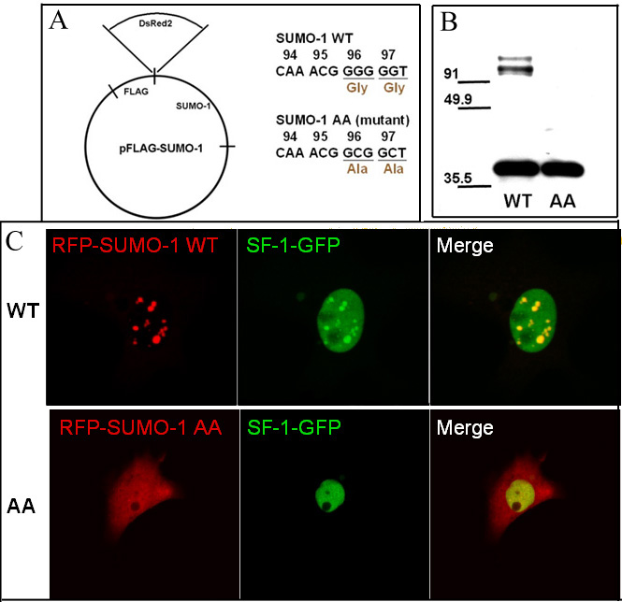
Figure1. (A) Plasmid construct of wild-type pFLAG-DsRed-SUMO1 (WT) and mutant pFLAG-DsRed-SUMO1 (AA). In SUMO-1 mutant, Gly-96 and Gly-97 has been displaced with Ala and can’t be covalently linked to SF-1. (B) Western blot of Y1 cells transfected with pFLAG-DsRed-SUMO1 WT (upper panel) and pFLAG-DsRed-SUMO1 AA (lower panel). Blots were probed with a FLAG-specific antibody. The size of FLAG-DsRed-SUMO1 is about 37KDs, and the bands larger than 91KDs in WT lane are sumoylated proteins. (C) Confocal scanning results of Y1 cells cotransfected with pFLAG-DsRed-SUMO1 and pDNA3.SF1-GFP-HA.
Cytoplasmic distribution of SF-1
Although SF-1 was always found in nucleus in previous study, in Fig.1C we can also find SF-1 outside the nucleus. First, we transfected pcDNA.SF1-GFP-HA in to Y1 cells, fixed and stained the cells with anti-SF-1 antibody, and used confocal laser microscopy to observe the sample. The signals of GFP and SF-1 overlap totally, which confirms that the green signal (GFP) is actually the red signal of SF-1 (Fig.2A). Next, Y1 cells were cotransfected with RFP and SF-1. RFP, which distributes homogeneously in cell, is used to mark the whole cell. Most of SF-1 localizes in the nucleus, and there are small spots of SF-1 beside the nucleus. The distribution of SF-1 is similar in 60% of the transfected cells. Spots of SF-1 near the nucleus are surrounded by the red RFP signal, which confirms the SF-1 outside the nucleus is in the cytoplasm (Fig.2B).

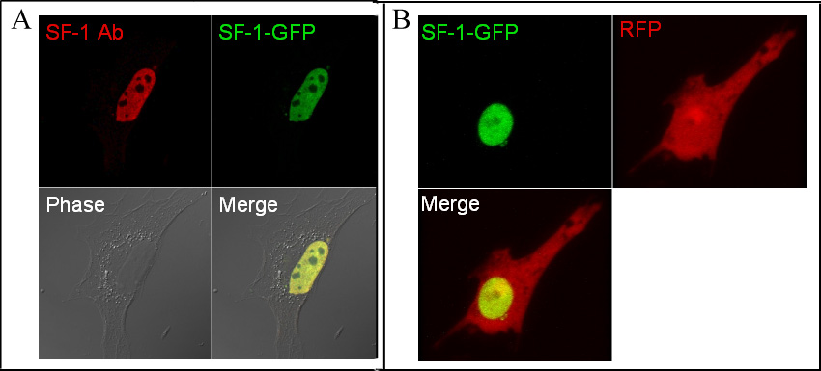
Figure2. (A) Confocal scanning results of SF-1 staining of Y1 cell transfected with pcDNA3.SF1-GFP-HA. (B) Confocal scanning results of cotransfection of pcDNA3.SF1-GFP-HA and RFP into Y1 cell.

To determine the exact location of the cytoplasmic SF-1, I transfected pcDNA3.SF1-GFP-HA into Y1 cell, fixed and stained the cells with antibodies of three different cytoplasmic marker (anti-actin antibody for microfilaments, anti-tublin antibody for microtubules, and anti-SCC antibody for mitochondria), and observed the cells under confocal laser microscope. The results show that the green SF-1 signal doesn’t overlap with the red antibody signal in these three cases, which indicates that cytoplasmic SF-1 may not associated with microfilaments, microtubules, and mitochondria (Fig.3).
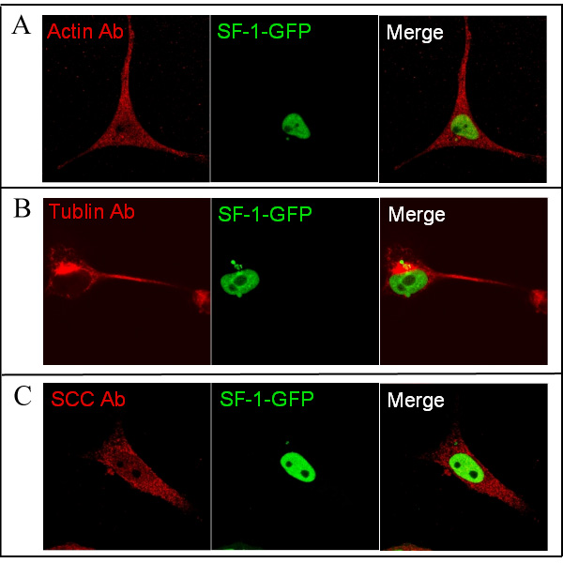
Figure3. (A) Confocal scanning results of actin staining of Y1 cell transfected with pcDNA3.SF1-GFP-HA. (B) Confocal scanning results of tublin staining of Y1 cell transfected with pcDNA3.SF1-GFP-HA. (C) Confocal scanning results of SCC staining of Y1 cell transfected with pcDNA3.SF1-GFP-HA.

I used LMB, the inhibitor of CRM1-mediate NES, to treat Y1 cell transfected with pcDNA3.SF1-GFP-HA to see if the cytoplasmic SF-1 is exported from nucleus through CRM1-mediate pathway (4). After LMB treatment, the amount of cytoplasmic SF-1 has not changed for 6.75 hours, which means that SF-1 may not contain a CRM1-mediate NES (Fig.4).
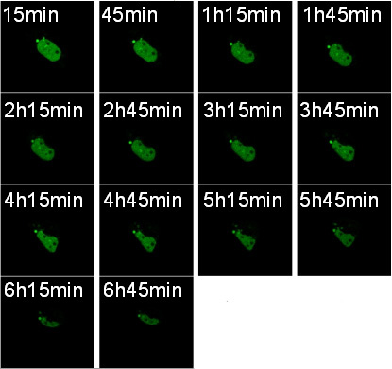
Figure4. Time series confocal scanning results of adding LMB to Y1 cell transfected with pcDNA3.SF1-GFP-HA. Time after treatment is labeled.

DISCUSSION
I have demonstrated that sumoylation of SF-1 may control the nuclear distribution of SF-1, and SF-1 would co-localize with SUMO-1 in PML nuclear bodies. The data suggests that SUMO-1 may direct SF-1 to PML nuclear bodies, where the sumoylation takes place, and SF-1 may also interact with other proteins in PML nuclear bodies. We can investigate details of the regulation mechanism by examining the interaction of SF-1 and SUMO-1 in living cells under different stimulus, such as cAMP treatment.
The experiment data showed that SF-1 would distribute not only in nucleus but cytoplasm, while the cytoplasmic location of SF-1 and the export mechanism from nucleus have not been clarified. By using electro-microscopy, the cytoplasmic location can be determined directly. In the LMB treatment experiment, the amount of cytoplasmic SF-1 has not decreased for 6.75hr after LMB treatment, which suggests that SF-1 may contain an LMB-independent NES. But I can’t exclude the possibility that some SF-1 may stay in cytoplasm after translation, or the cytoplasmic SF-1 may be so stable that it may not decay in 6hr. We found it is reported that AR contains an LMB-independent NES sequence (5), and we performed the multiple sequence alignment of SF-1, FF1b and AR. The alignment results show that a region in ligand-binding domain (LBD) of SF-1 has high homology with the NES of AR (Fig.5). The results indicate that the export mechanism of SF-1 from nucleus is mediated by the LMP-independent NES in the LBD of SF-1.
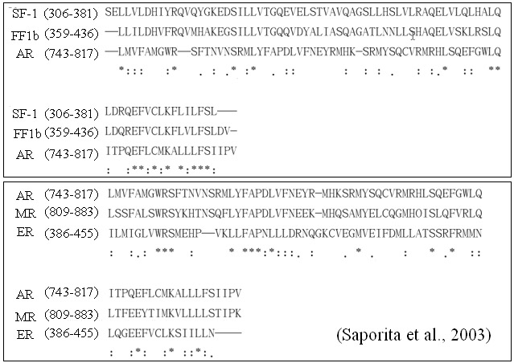
Figure5. Alignment results of SF-1, FF1b (SF-1 homologue) and AR, compared with the alignment of AR, MR and ER. Star stands for identical residue, double dot stands for highly conserved residue, and single dot stands for minor conserved residue.

REFERENCE
- G. Ozisik, J. C. Achermann, J. J. Meeks and J. L. Jameson, SF1 in the development of the adrenal gland and gonads, Horm Res. 59, 94-98 (2003)
- A.-A. Li, E.F.-L. Chiang, J.-C. Chen, N.-C. Hsu, Y.-J. Chen and B.-C. Chung, Function of steroidogenic factor 1 domains in nuclear localization, transactivation, and interaction with transcription factor TFIIB and c-Jun, Mol. Endocrinol. 13, 1588-1598 (1999)
- F. Melchior, L. Hengst, SUMO-1 and p53, Cell Cycle 1(4), 245-249 (2002)
- Tweeny R. Kau and Pamela A. Silver, Nuclear transport as a target for cell growth, DDT 8(2), 78-85 (2003)
- A. J. Saporita, Q. Zhang, N. Navai, Z. Dincer, J. Hahn, X. Cai and Z. Wang, Identification and characterization of a ligand-regulated nuclear export signal in androgen receptor, J Biol Chem. 278(43), 41998-42005 (2003)

