(研習報告與討論心得)
前提:
這次暑假由於我是跟葉明憲同學在同一間實驗室,而他也有修研習報告與討論, 而我們這次暑假做兩個project,一個為老鼠行為測試,另一個為觀察老鼠小腦發育過程.前者由葉明憲同學報告,我是報告後者.
上課報告內容:
Project II the observation of the development of the mouse cerebellum
這project主要分為六個步驟,分別為(1)解剖取腦 (2)脫水浸臘 (3)將sample做成臘塊切片 (4)脫臘和rehydration (5) H&E stain (6)觀察.
- 解剖取腦:我以放教學片的方式跟大家介紹.而取腦最重要的原則就是延髓以上的部分(包含腦幹 . 小腦 . 大腦 . 嗅球等.)都要完整取下,腦殼要全部剝除否則會影響切片(因為腦殼太硬),腦膜也要去除掉(以方便後來的操作,如將腦部切成幾部分 . 做臘塊等 , 因為腦膜包覆在腦的外部,會擋到你的視線,不利操作.且腦膜會使的腦無法平整的放在做臘塊的模具,會影響接下來的切片,因為你必須不斷的修臘塊,直到你要的那一個面出來,這樣也很容易將重要的腦組織不小心給修掉.).絕對不能傷到腦部,一個刮痕都不行有.因為這樣會影響你的實驗觀察.所以這一步驟是很技術性的,需要靈巧的雙手和極高的注意力.取完腦後,先將其放在10%的formaldehyde保存.
- 脫水浸臘:將腦依序以50% . 70% . 80% . 90% .100%的酒精脫水,每一次都要浸泡40~60分(依老鼠的年齡決定,一周以前40分就可,三週以上最好60分鐘.).若脫水的不完全,會影響到後來的浸臘,浸臘不完全會影響後來的切片.接著換泡在100%的xylene裡頭,主要是要去除酒精(若腦裡面有酒精殘留就會使的某部分的腦組織無法浸臘,因為酒精跟臘是不互溶的.而xylene可以除掉殘留再腦部的酒精,且xylene可以與臘互溶.)下一步是泡在半臘裡面(50%xylene,50%臘)四個小時,主要是要讓臘進入腦組織裡面.再來就是泡在100%的臘裡一個晚上(10小時左右).這步驟要做的好,因為腦部若有一點點的地方沒有浸到臘,這個地方將會很硬,當你切片切到這地方時,根本無法繼續切下去,而且也會傷害刀片.(泡半臘跟全臘時,要放於加溫箱裡,溫度要高於或等於62.5度,不要太高也不能太低,因為臘在小於這溫度的環境下就凝固了,這時臘根本跑不進腦裡面,而太高溫會嚴重破壞蛋白質,影響你來的操作,如須要特定蛋白質做binding的染劑就無法使用.)
- 將sample做成臘塊切片:做臘塊時要將sample的底部(切面,因為不可能將整個腦做成臘塊,必須先切成幾部分,這要在脫水之前做,不然脫水完組織會變很硬,)平貼在模具的底部,因為接下來的切片就是從這個面開始切.做臘塊時,是要讓臘液緩緩的凝固,不要讓任何氣泡產生,否則臘塊裡會有空洞出現,這樣切出來的片(約6um厚)在放入後來的溫水中延展,會延展的很難看,切片會有部分皺縮起來,使的你切片無法完整的平鋪在玻片上頭,若你要觀察的重要部位也皺縮了,那一切都白做了.所以臘塊絕對不能有空洞出現在裡頭.做完臘塊接下來就是切片,切片是手工操作的(我本來以為是機器自動切的.),是很須要超高技術的步驟(連我們老師都要費一番功夫.),臘塊的溫度環境的溼度,刀口的完整度和轉動切片機的速度都會影響你切片能不能成功.我大概練到10個切片只有兩三個是可以用的.切完的片要小心的放到一個溫水槽中,溫度約42度,切片平整的鋪在水面上,讓切片皺縮的地方藉由水跟臘片之間的吸引力,將其拉開.而之前所說若切片上有破洞,會使的切片四周所受的拉力不均,使的有些地方更皺,有些地方被撕裂,太嚴重的話就不能使用.在溫水槽中延展完的切片利用玻片撈起,使切片也是平整的貼在玻片表面.
- 脫臘和rehydration:將平鋪在玻片上的切片拿去脫臘和重新吸水,步驟就如投影片中所述.在到染色之前,切片都要保持潮濕.(切片會緊貼在玻片上,部會掉下來.)
- H&E stain:這部分我在投影片上有說的很詳細,所以在這邊就略過.
(第11張到第13張投影片是我對小腦的組成神經細胞.不同神經細胞之間的連接.小腦的功能和小腦皮層的形貌(molecule layer . Granule cell layer . Purkinje cell)所做的簡短介紹,這也不多做補充.)
- 觀察:這部分我也在投影片上有整理,在這裡也不多做解說.
  - 第14到第17張投影片,是我觀察五個時期的老鼠小腦所得的觀察結果.(分別為剛出生.一週大.兩週大.三週大和四週大)
  - 第18到第25張是我根據發育課本(Principle of Development ,Wolpert ,second edition P386~389)和從Chemoarchitectonic Atlas Of the Developing Mouse Brain by Jacobowitz Abbott擷取下來的圖片(投影片第23張)還有一篇paper(Pattern Formation In The Cerebellar Cortex by Carol L. Armstrong
And Richard Hawkes Biochem. Cell Biol,Vol.78,2000)所想像小腦發育的過程.但那時已是八月底了,我沒有再繼續找資料或做實驗去證實.

*這是我在最後一張投影片所做的結論:
- I think that initially the granule cells ,the Purkinje cells and other neurons of the cerebellum arise from the ventricular proliferative zone on the roof of the fourth ventricle. The Purkinje cells would migrate to the layer a little far from the proliferative zone. The granule cells seem to stay in the position near the proliferative zone, and finally form the external granular layer that can be seen until the age of two weeks (P14).Even if at the stage of P14, you can see one layer of the granule cells that is a cell thick .
- the Purkinje cells will become bigger and bigger , and they change little in size since P14.I consider the Purkinje cells mature at the stage of P14 or a little earlier. And the Purkinje cells must have many functions ,because they have the big cell bodies, like the liver cells. The big cell bodies indicate they need more space to store or make the necessary enzymes like some neural transmitters for the chemical reaction or transferring neural information .
感想:
在剛到中研院分生所N217實驗室時,起初的三個星期我很熱血,因為每樣東西都很新鮮,但每天要趕進度所以幾乎到晚上八九點才能回去,一天有12個小時都在實驗室,大約在七月底熱心慢慢沒了,也體會到做實驗的煩悶和辛苦.開始想自己未來真的要走研究的路線嗎?但在實驗室,老師,學長和助理都對我們不錯,常鼓勵我們給我們意見,像是怎樣做好一個實驗.實驗如何設計,怎樣的實驗態度,實驗的數據要怎麼整理歸納還有未來該如何規劃等等.且我們每個星期老師規定我們一定要參加實驗室的meeting,在meeting中了解要怎樣報論文,怎麼表達,準備報告的方向,還有哪些問題該問演講者,哪些不該問等等的,雖然熱心越來越低,不過透過慢慢調適自己的心態和想法,還有老師.學長姊.和其他助理阿姨的鼓勵,我還是能夠每天認真的做實驗,且找些有趣的東西維持自己的興趣.到八月中,我們開始趕實驗,整理數據,準備八月底meeting時的報告.那時真的是自己學最多東西的時候,因為自己要在每一比數據中找出出問題的老鼠(我們是在做對一批隨意人為突變的老鼠(EMS)做行為測試,找出表現最差與最好的老鼠,也就是葉明憲同學報告的部分.),而分析的方法老師要我們自己去找或自己設計,那時苦思了很久才想出一套自己的統計方法,在那過程中有很多奇想,自己也將這些想法東湊湊西湊湊把它們連接成一連串合邏輯的公式,雖然不是什麼了不起的事,但靠自己得來的東西感覺真的很棒.這是其中之一的project,也就是測試老鼠行為的project主要用意是訓練我們的觀察力.分析能力和想像力.另一個project,也就是我報告的部分,是費去我最多時間的,就是去對小鼠的腦做摘除.脫水.進臘.乾燥.切片及染色,觀察小鼠從出生,一週大.兩週大.三週大.四周大各個時期腦部的發育狀況.尤其是 摘除和切片這兩項技術練了很久,有時真的做到快發瘋.而這一project因該是訓練我們的耐心和手的靈活度吧!最後一個project我們並沒有完成,只做到染色完做初步觀察而已.
我提出老鼠小腦發育過程的model也沒有繼續去證實,若有時間讓我繼續做下去的話,我想對老鼠從出生到兩週大這段時間取更多sample做實驗,而每個sample之間的年齡差縮到2~3天,做更測底的觀察,看小腦表層的molecule layer
. Purkinje cell和 Granule cell layer是如何發育完成到他們成熟時所處的相對位置,還有Purkinje cell大小的變化.而以我們的方法也只能去看小腦型態在發育過程中的變化,分子層次的變化我們必須要學其他的技術,如電生理.單就我暑假學的這個簡單的技術,也可以應用到不同突變鼠同一部位的切片觀察,去比較某一基因的突變或knock out對小腦發育的外部型態之影響,由這推出這基因的大致功能,引導接向來分子層次的實驗方向.
補充:
以下是我projectI的實驗數據整理及結果討論(於暑假時已完成)
Project I : The mice behavior tests:
- Open field
(一)Introduction:
1.an abbreviated drawing
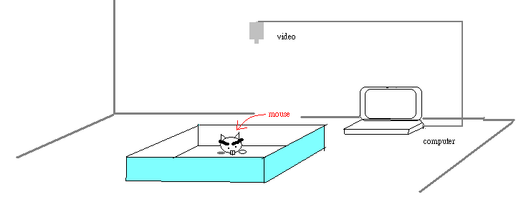
2. two forms of data
The Route
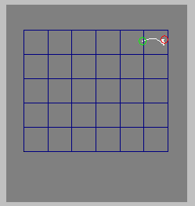
The data
Trial name ,001.hvs
ISI msec ,200
Field (X) meters, .6
Field (Y) meters, .5
Slice start secs,off
Slice end secs ,off
Subject was ,mouse
Descriptor was ,second
Duration secs ,180
Total path mtrs ,.19
% time moving ,4.3
% cells used ,6.6
Cells entered ,1
Cell-entries ,1
Special entries ,0
% Time specials ,0
% Time in cells ,was
000.0, 000.0, 000.0, 000.0, 000.2, 099.8
000.0, 000.0, 000.0, 000.0, 000.0, 000.0
000.0, 000.0, 000.0, 000.0, 000.0, 000.0
000.0, 000.0, 000.0, 000.0, 000.0, 000.0
000.0, 000.0, 000.0, 000.0, 000.0, 000.0
Remark ,None
END ,001.hvs

(二) Result
(1)Although this test have a lot kinds of data,I would focus on the total path,%cell used,and %time at the center zone.
(2)The data show the high correlation between the three parameters.But the result of the first time test have large difference with the result of the second time test.
i. Correlation coefficients (I):
The correl between %cell used and %time in the center:
- first time:0.743 (b) second time:0.752
The correl between the total path and %time in the center:
( c ) first time:0.855 (d) second time:0.718
The correl between the total path and %cell used:
(e) first time:0.881 (f) second time:0.823

→ If we define the mice spent more time going through the center or staying in the center are braver, the braver mice seem to have better activity. The data of Table I also has the trend.
ii. Correlation coefficients (II)
The correl between the two times of the tests
(g) about the total path:0.636 (h) about %cell used:0.731
(i) about%time in the center:0.355

→the data from the two times of tests is very different, and the members of the rank of the top 9 about %time in the center at the first time test are almost different from the one at the second time test. What are the reasons causing this different?

Table I
iii. Correlation coefficient (III)
The correl between %cell used and the activity of the hole board Test:
(j) at the first time:0.386 (k) at the second time:0.224
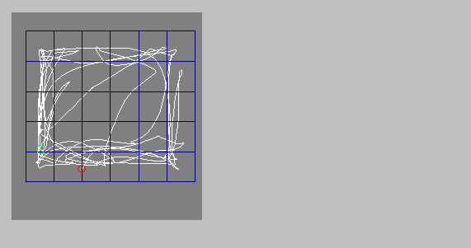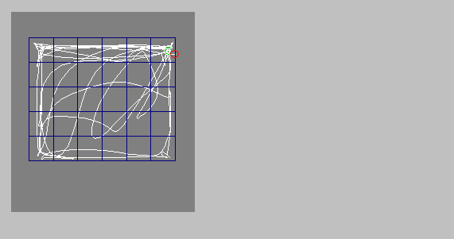
10530F(1) (a) 10530F(2) (b)

Activity
first:55(20) second:57(16) [The performance of mice NO.10530 in open field(a).(b) and in hole board(Activity)]
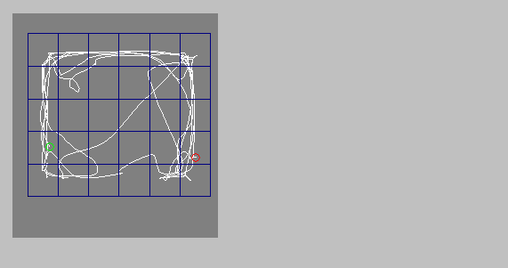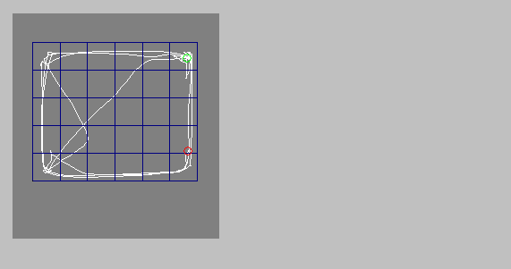
10371M(1) ( c ) 10371M(2) (d)
Activity
first:32(31)second:37(31) [The performance of mice NO.10371 in open field(c).(d) and in hole board(Activity)]
→ we can find that the mice had went through more cells, not because they are more curious.I think the mice are very up-and-about, but they may be less curious. the two behaviors have little relation.

- Hole board
(一)Introduction
an abbreviated drawing
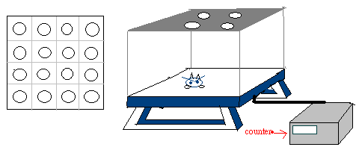
(二)Result
the data in Table II
*The correlation coefficient between first tests and second tests is 0.629
*The average of the first set of tests is 60.25;the average of second is 56.167
(1)Take a look at the values of the averages of the two times of the tests, you can find that the average of the second time is smaller than the first time. does it result from that the mice have remembered this environment of hole board, and when they came back to the platform of hole board, they would lose a little interest in searching the holes?
→ the correlation coefficient between the difference of the two times of tests at hole board and the scores of the performances of the mice at water maze is only -0.39424.
→the mice did not really remember this environment of the hole board.

Table II
(2) There are so many conditions that may cause the big difference between the two times of tests for some mice:
1. Feeling tired at one of two tests.
2. Having bad condition of the healthy at one of two tests.
3. The positions where I did the two tests are very different.(light , noisiness …. )
4. When did I do this experiment. ( morning . afternoon ….)
(3)I consider that the smaller values of the activity in the hole board tests dose not indicate that the mice must be less curious. Becausesome mice explore the holes very carefully like the mouse which ID is 10491 or some walk very slowly or alertly, they would have the
smaller grades about the hole board test.

- Water maze
(一)Introduction
an abbreviated drawing
1 st day | SE X 3
2 ed dat | SE X 3
3 th day | SE X 3
4 th day | SE X 1  SW X 2
5 th day | SW X 3
6 th day | SW X 1  N X 2
7 th day | N x 3
8 th day | N X 1  SE X 2
9 th day | SE X1  Prob x 1
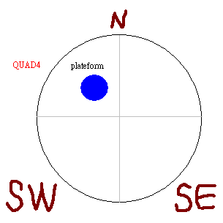

(二)Result
The way to score how smart the mouse is:
Function:100-(100 X PATH/21.96)+100-(100 X Time/90)+100 X% of path in the zone around the platform(Table III)
I use this function to calculate every test of every mouse and then I get the
average of scores of three tests within one day for every mouse. Finally, Because water
maze have lasted for nine days, I have nine average scores for each mouse. The nine
scores must be averaged again. The result is the grade of the performance of each mouse
in water maze.
I create this function, so why?
(1) the most smart mouse would spent less time and past the smallest distance to find the platform.
(2) Some mice that can not find the platform very quickly may due to they are unfortunate . But, if the mice really rememberwhere the platform is according the landmarks around the pool, they will try their best to find the destination around the
platform. So the value of QUAD4% will be high.
(3)If the mouse can not find the platform within 90sec,I will add this function (the final score-100) to avoid the error made by that the mouse was lazy to move and fortunately always stay within the quadrant containing the platform.

Table III
Some examples to prove this function can work well:
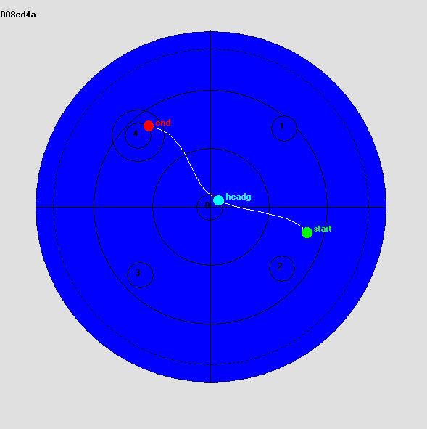
Time:3.2sec
Path:0.78m

QUAD%:48.6%
SCORE:241.49

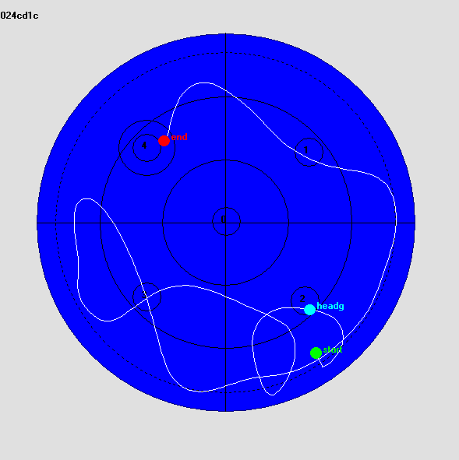
Time:26.7sec
Path:5.38m
QUAD%:11.2
SCORE:157.03

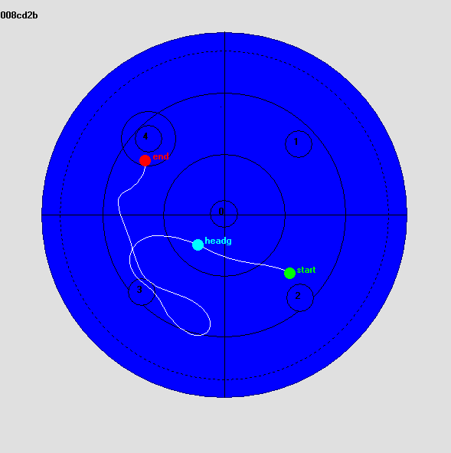
Time:9.5
Path:1.93m
QUAD%:13.3%
SCORE:193.96

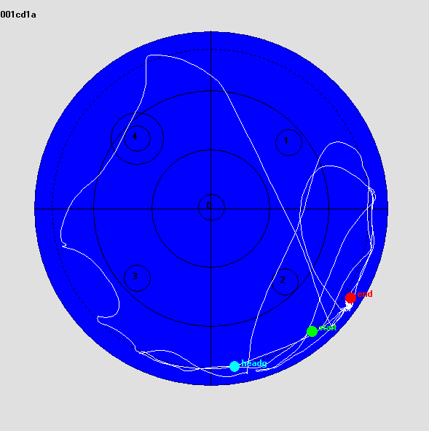
Time:90sec

Path:10.55m
QUAD%:8.7%
SCORE:-39.34

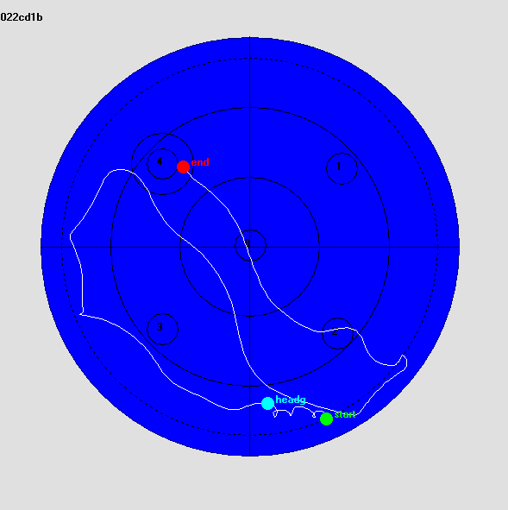
Time:37.6sec
Path:4.09m
QUAD%:24.7
SCORE:164.3
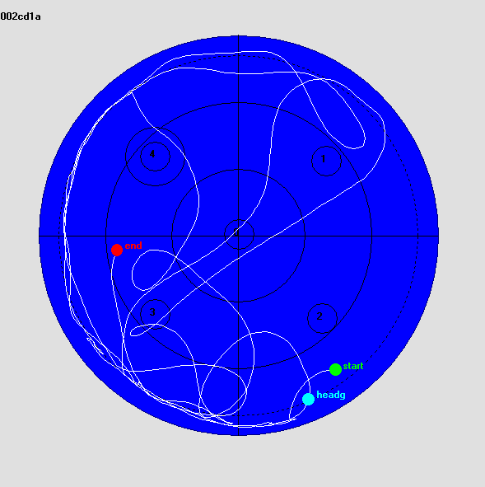

Time:90sec
Path:14.57m
QUAD:21.3%
SCORE:-45.05

The disadvantages of function:
I think this function is just able to divide those mice into some classes roughly. It just perform the trend about the behaviors of mice .If you get two scores, one is 140, another is 155,you can not say the mouse getting 155 is more smart than the one which get 140.
Some ways to improve this function and the experiment:
- to reduce the range of the zone the QUAD4% were calculated from.
- to avoid the man-made errors as could as passable. like putting mouse. In same way and in same position and make mouse face the same direction for every set of every test. the way to put mouse into water has to be very gently and so on.
- when every thing (pool, platform, the level of the water surface) sets well, do not to move they until all tests finish.
- to take care of the sensitivity of the camera all time and make sure the video work well. to clean the pool once after every day tests. To make the light mild against the reflection of water surface or other thing which have the smooth surface.
(三) Result from my analysis
(1)The distribution of the scores of my 36 mice
(2) The two mice that performed poorest( 0xx is the NO. of the mice ex:001 , 026 )
(3) Genius

(4) The mice that had good learning ability.

