Design and Synthesis the medicine,Camptothecin(CPT) analogue,the DNA topoisomeraseI&II inhibitor

Shin Da Chen

Abstract
Camptothecin is anti-cancer drug which extract from Camptotheca acuminata tree that grow in China. We know CPT can inhibit human topoisomeraseI. Topoisomerase can relax supercoiled DNA, and let supercoiled DNA relax. Then the DNA can replication and the cell proliferation. But CPT can bind the topoisomeraseI and topoisomeraseI SUMOylation then topoisomeraseI would loss his ability. Now, we want to synthesis the CPT analogue because CPT is very toxin and not only kills cancer cells but also harms normal cells. Another disadvantage is CPT is low solution in water. So we design less toxin and better solute-ability’s CPT analogue. And use many organic chemistry techniques to combine this compound.

Introduction
Camptothecin(CPT) analogue could bind with DNA or topoisomeraseI and form complex by covalent bond. We expect these medicine apply to explain the situation of the interaction between CPT and DNA or topoisomeraseI. We know other CPT analogue have already made like CPT-11 previously and have good curative effect. It good anti-cancer drug. So we try to make another CPT analogue.

Methods and Materials
Procedure
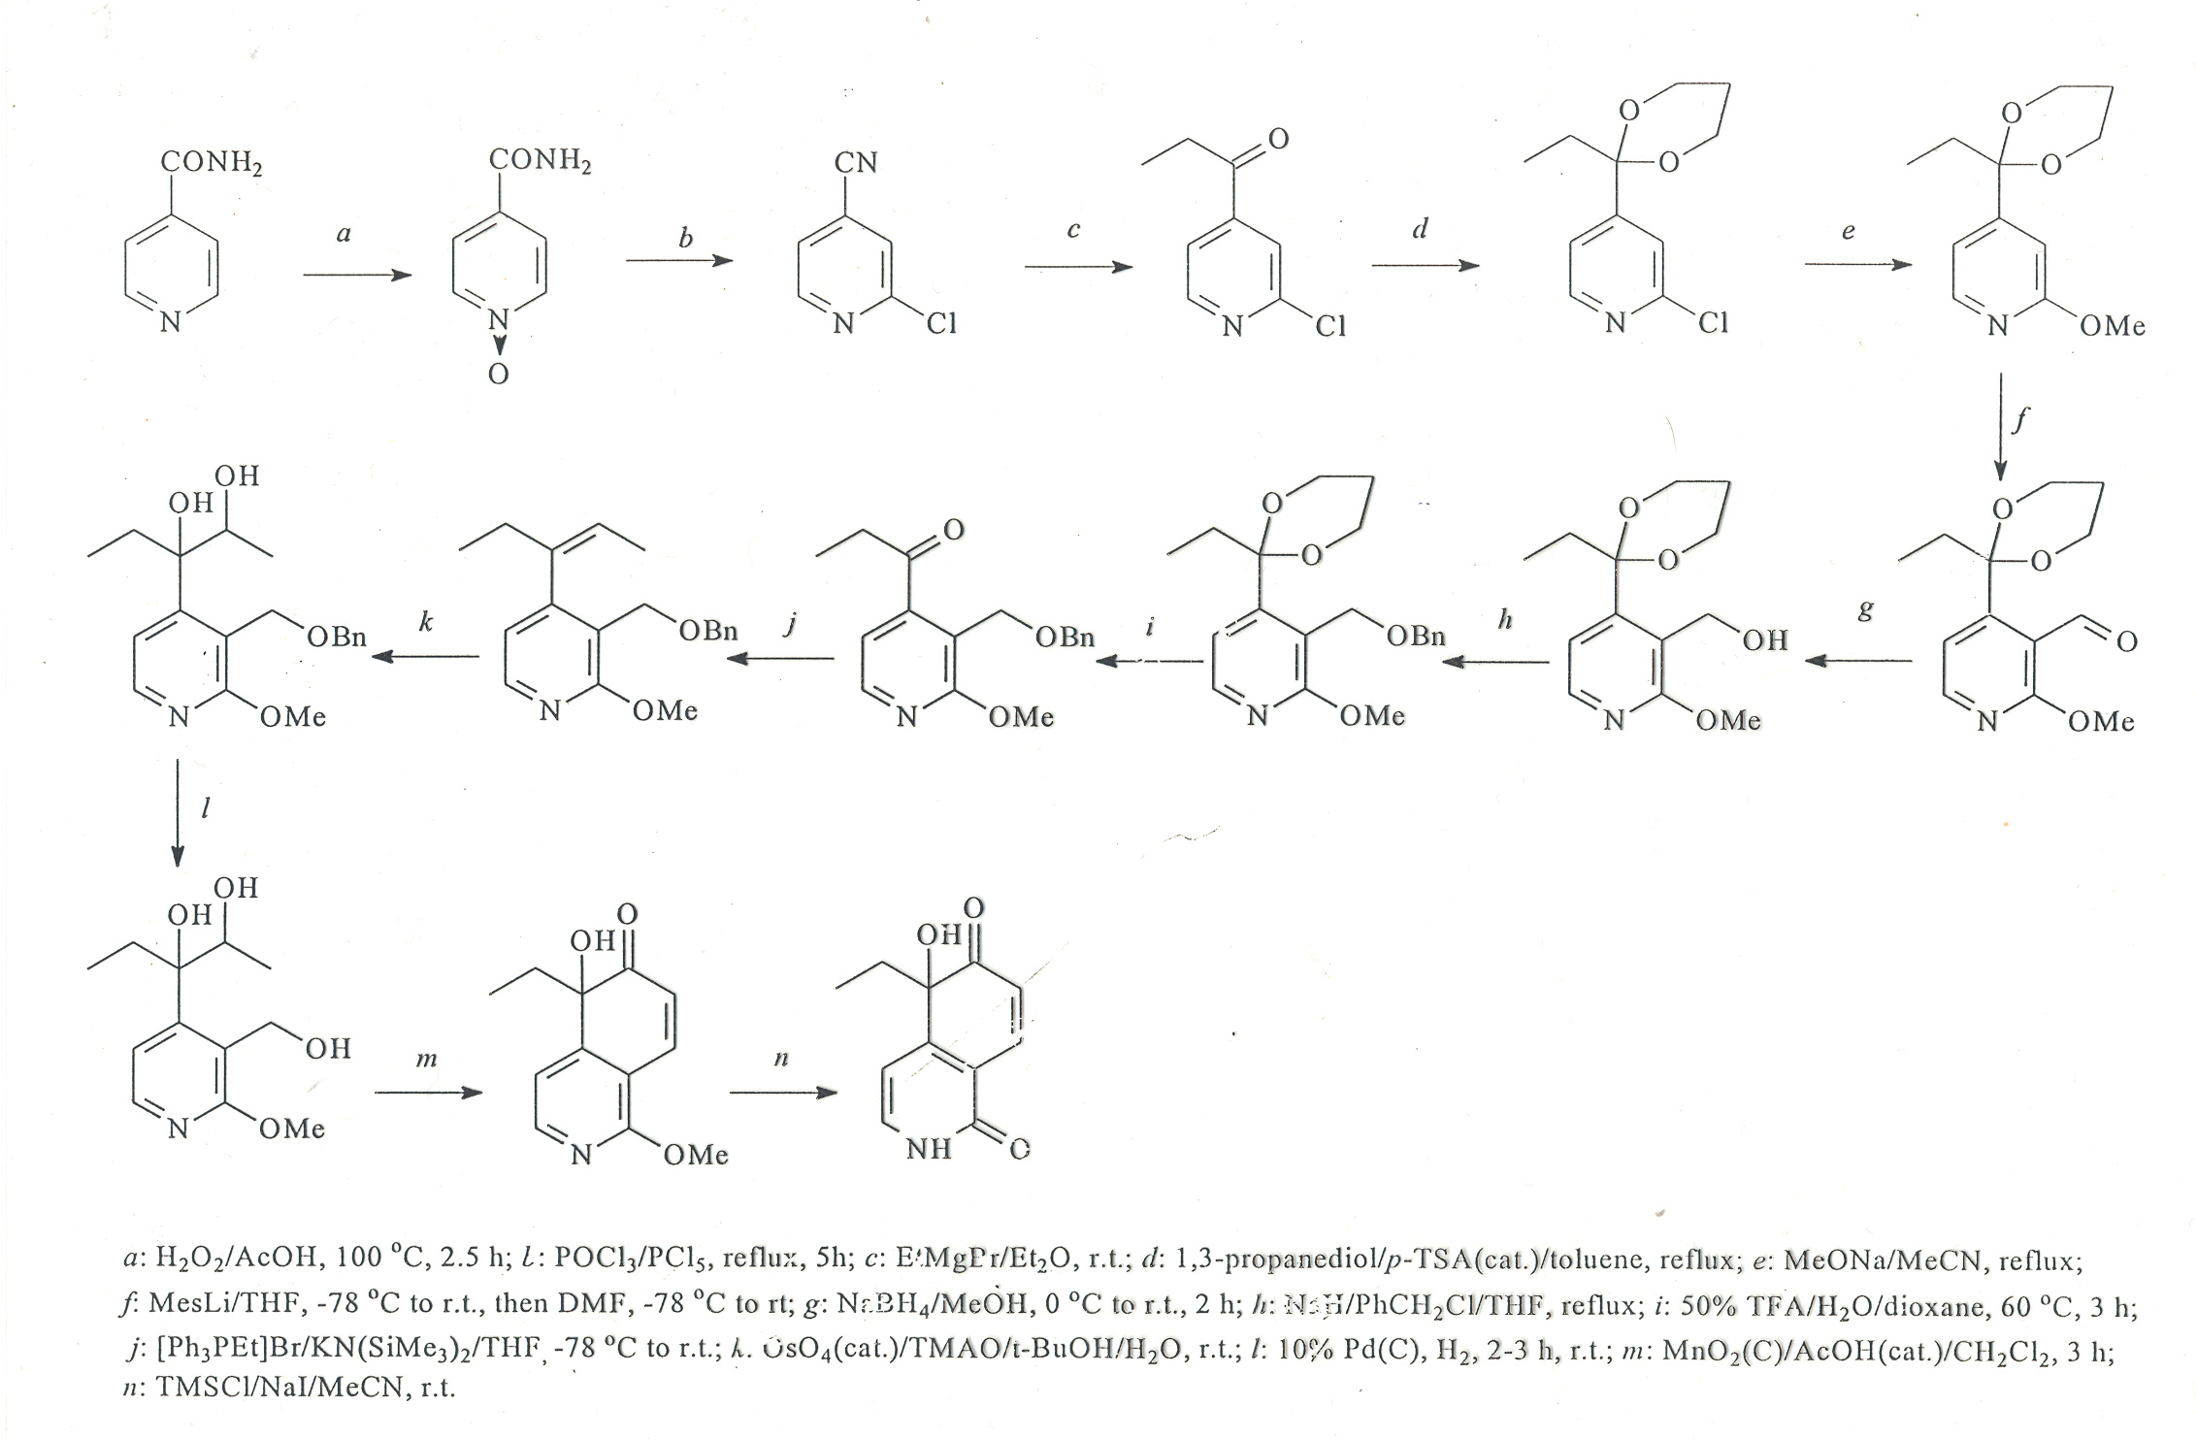

Methods
TLC
Thin layer chromatography can analysis the result compound is like our design or not. Use microtube to take a little compound solution and hit at TLC plate. Then push into a bottle with organic solvent. Then analyse the Rf.
NMR
Use nuclear magnetic resonance spectroscopy to measure the chemical structure and purity of compound. We make sample with several mg of compound and solute in CDCl₃.And go to operate NMR spectroscopy.
Materials
We use isonicotinamide reaction with glacial acetic acid(CH₃COOH) and hydrogen peroxide(H₂O₂) at 100^{O}C for 2hours in reactor BMD300 and product isonicotinamide N-oxide. Then use isonicotinamideN-oxide to mix with phosphorus pentachloride(PCl₅) and phosphoryl chloride(POCl₃), and heat to 70~80ºC for 3hours.

Results
At ours first reaction, ours yield of product is 80.6%. This is the highest. Then several times is 70~80%. The ideal yield is 90%
The second reaction is low efficiency. Ours yield is 50~70%. At this step we got a lot of compound mixture. So we must use tmany technique to separate these analogue and purity the compound. We take two NMR photo to see the compound is that we want or not.
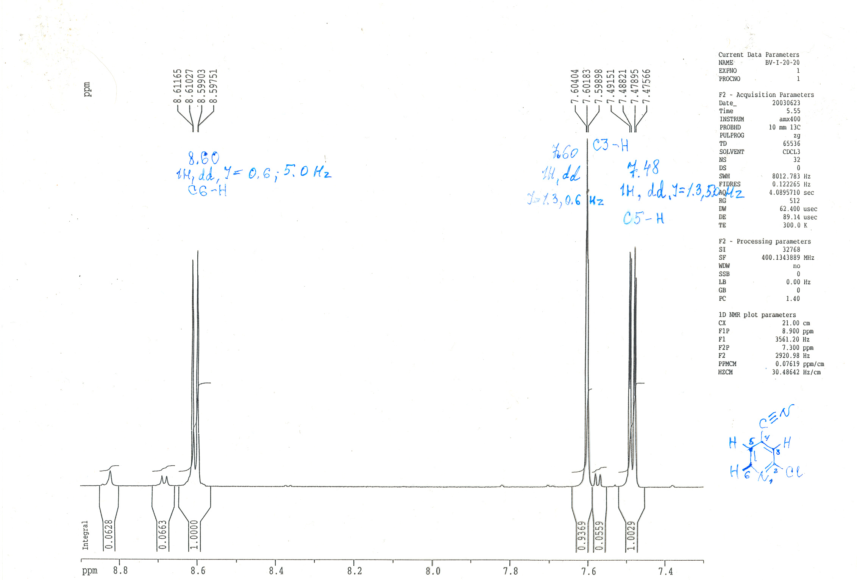
And we can see the compound is that we want. But we failure to synthesis the final compound. So the result is failure.

Discussion
The result yield is always lower than standard. We think the major problem could be operation. Because the operate technique must be careful and patient, or would loss some compound. Little miss in one step accumulate would be much enough to make this inaccuracy.
We could not synthesis the final compound because we must make about eighty step reaction!! And when every step we must waste time to purify and extract the compound, it always cost several days even a week. So I say patience is very important.

Reference:
Scarborough, A., Su, T.L., Leteutre, F.F., Pommier, Y. and Chou, T.C.
DNA interaction and topoisomerase II inhibition by the anttumor agent 3-(9-acridinylamino)-5-hydroxymethylaniline and derivatives. Bioorg. Chem. 24: 229-241, 1996.

