研習報告與討論

蔡騰寬901607
中研院生醫所林陽生老師實驗室

Interaction of TCF4 with DP103 and FHL3

Abstract

Wnt signal pathway, especially β-catenin/TCF4 complex, plays a critical role in colorectal cancer development. By means of yeast two-hybrid assay and ECL Western blotting, two kinds of recently discovered proteins, DP103 and FHL3, respectively manifest interaction with TCF4.

Introduction

Tumors of the colorectum appear common in western population. Studies of inherited and sporadic colorectal cancer have revealed that it results from the accumulation of multiple independent genetic mutations. By molecular genetic analysis in Drosophila, Caenorhabditis elegans, Xenopus, and Mus musculus, it has demonstrated that Wnt signaling plays a crucial role in the etiology of colorectal cancer and that the function of Wnt signal transducers is highly conserved among species.
When Wnt signal is absent, the signal transduction pathway is blocked because free β-catenin is destroyed by a multiprotein complex containing tumor suppressor adenomatous polyposis coli (APC), Axin and glycogen synthase kinase 3β (GSK3β) (Figure 1). Phosphorylation of β-catenin by GSK3β earmarks it for ubiquitination and subsequent degradation by the proteasome pathway. Both APC and Axin interact with β-catenin and facilitate its phosphorylation. Consequently, the levels of cytoplasmic β-catenin are low, and T cell factor 4 (TCF4) in the nucleus is repressed.
In stimulated cells, the cytoplasmic protein Dishvelled is recruited to the membrane and inhibiting the Axin complex by directly binding to it. Therefore, β-catenin accumulates and eventually translates into the nucleus where it interacts with TCF4 to coactivate Wnt target genes. Interestingly, the function of TCF4 depends on partner proteins and on simultaneously signaling by other signal pathway. Thus, TCF4 plays a key role in integrating multiple positional inputs.
The activity of TCF4 is tightly controlled by negative regulators binding to it, such as Groucho family. Since TCF4 is a transcription factor, we expect there should be some other kinds of regulators as well. Taking a series of analyses inclusive of yeast two-hybrid assay and ECL Western blotting, the results presented here support that DP103, a member of the DEAD box family of putative ATP-dependent RNA helicases, has potential binding to TCF4 in human cells, so do FHL3, an actin-binding protein.
Materials and Methods

TCF4 Cloning
TCF4 containing template, C30, was amplified by polymerase chain reaction (PCR), and the resulting product was purified in the use of gel elution. On the other hand, the vector pAS2-1 was digested by restriction enzyme SalI and EcoRI so that ligation could be taken between pAS2-1 and TCF4 (Figure 2). The consequential products were transformed into E. coli strain MC1063P10 for large scale plasmid preparation. Furthermore, the cDNA library was produced with the vector pACT2 in the same way (Figure 3).

Yeast Two-Hybrid Assay
The vector pAS2-1 coded with TCF4 and the vector pACT2 comprising cDNA libraries were concurrently imported into the yeast strain AH109 (Figure 4). The transformed AH109 was plated on medium lacking adenine, histidine, leucine and tryptophan but adding X-α-gal. After incubating, the blue colonies was isolated and streaked again for α-galactosidase activity (Figure 5).

DNA Sequencing
Plasmids rescued from yeast were retransformed into E. coli for Sanger sequencing by means of 2’, 3’-dideoxyribonucleoside triphosphates. Alignment was accomplished on the computer program to find out the presumable genes.

ECL Western Blotting
The conceivable protein made along with Flag on the vector pRK5 and TCF4 constructed together with HA on the vector pAS2-1 were shot into Mus musculus cells by calcium chloride contemporarily. The extracted proteins co-immunoprecipitated by anti-Flag and anti-HA were in search of fluorescent spots.

Results

Transformed E. coli Is Expressible
To determine the success of transformed E. coli, we performed two different instruments showing that recombinant DNA had transported into E. coli. The customary mode is available to cut plasmids from chosen colonies with restriction endonucleases after boiling miniprep. In case of vectors actually including TCF4, there should be two separate bands of single colony on the agarose gel. The more convenient method is to pick several colonies as template for PCR. Subsequently, the PCR products are operated on electrophoresis, and the bands imply success. Although the latter method seems quicker, it still needs some times to culture favored bacteria in the medium for large scale plasmid preparation. Moreover, it has to know the exact sequence for primer design. Hence, it depends on situation to determine which one should be used.

Interaction of TCF4 Is Observable in Yeast
Among hundreds of colonies growing on the plate, less than 10 % displayed blueness. In order to reduce false positives, probably due to prey protein automatically activated, and yield high stringency, we proposed to restreak blue colonies twice. This eliminated about half of the colonies. Additionally, plasmids of the remains were recovered back to E. coli for yeast two-hybrid assay. The outcome could further confirm the interaction between likely protein and TCF4. Besides, it economizes much time and resources on advanced examinations. After submitting the sequences to NCBI, two species of genes in human genome unveil, i.e. DP103 and FHL3.

Interaction of TCF4 Is Detectable in Animal Cell
Owing to the probability that protein might alter their 3-D conformation in yeast, we intended to inspect the more native circumstance in Mus musculus cells. The effect of ECL Western blotting exhibited that DP103 indeed interact with TCF4 as two separated fluorescent bands on ECL film, so does FHL3.

Discussion

Benefits in Yeast Two-Hybrid System
This system provides a sensitive way for discovering weal and transient protein interaction what may not be biochemically detectable but crucial for proper functions of complex biological systems. The sensitivity is primarily attributable to high-fold amplification of positive signals in vivo. By the way, proteins are apt to be in their real conformations which may lead to increased sensitivity and accuracy of detection.

Limitations in Yeast Two-Hybrid System
Though yeast two-hybrid system is a useful implement assaying protein interaction, it still has potential failures. Some bait proteins may have intrinsic DNA-binding transcriptional activating properties so that deletion of certain potions of bait proteins is required to avoid unwanted activity. In addition, the fusion of DNA-binding domain or activation domain may occlude the normal site of interaction or impair the appropriate folding of the hybrid protein, and thus interfere with the capability of two hybrid proteins to interact. Finally, the conditions in yeast may not allow the posttranslational modifications needed for interaction of some mammalian proteins. As results, we attempt other system, e.g. mammalian cell culture.

Proposed Model for TCF4, DP103 and FHL3 Expression
Recently some researches indicate that DP103 has RNA helicase activity, based on its DEAD box domain. As results, it can unwind the hairpins frequently found in the 5’-leader of eukaryotic mRNAs. On the other hand, DP103 exhibits a native transcriptional repression function which localizes to the C-terminal region of the protein. Physiologically, DP103 is expressed predominantly in the testis and is expressed at lower level in other steroidogenic and nonsteroidogenic tissues. For FHL3, it is highly expressed in skeletal muscle. FHL3 also inhibits α-actinin-mediated actin bundling which implicates FHL3 as a significant regulator of actin cytoskeletal dynamics in skeletal myoblasts. More important, studies reveal that FHL3 can repress transcription.
Combining the facts above, we speculate that both DP103 and FHL3 repress TCF4 activity by directly binding to its regulatory regions while Wnt signal turns off. Once stimulating, β-catenin enters nucleus and interact with TCF4 complex releasing DP103 and FHL3 into cytoplasm. The unattached DP103 may serve as a translation activator of Wnt target gene for its RNA helicase activity. The free FHL3 may further unload β-catenin from adherens junctions by means of destroying actin bundling. Therefore, it seems that DP103 and FHL3 have opposite functions, repression and activation, in regard to Wnt signal.

References

- Eduard Batlle, et al. (2002). β-catenin and TCF mediate cell positioning in the intestinal epithelium by controlling the expression of EphB/EphrinB. Cell 111, 251-263.
- Imogen D. Coghill, et al. (2003). FHL3 is an Actin-binding protein that regulates α-actinin-mediated Actin Bundling. Journal of Biological Chemistry 278, 24139-24152.
- Jeremy Turner, et al. (2003). The LIM protein FHL3 binds basic Krüppel-like factor/Krüppel-like factor 3 and its co-repressor C-terminal-binding protein 2. Journal of Biological Chemistry 278, 12786-12795.
- Jeroen Roose, et al. (1999). Synergy between tumor suppressor APC and the β-catenin-TCF4 target TCF1. Science 285, 1923-1926.
- Marc van de Wetering, et al. (2002). The β-catenin/TCF-4 complex imposes a crypt progenitor phenotype on colorectal cancer cells. Cell 111, 241-250.
- Mariann Bienz, Hans Clevers. (2000). Linking colorectal cancer to Wnt signaling. Cell 103, 311-320.
- Mark Peifer, Paul Polakis. (2000). Wnt signaling in oncogenesis and embryogenesis–a look outside the nucleus. Science 287, 1606-1609.
- Qinglin Ou, et al. (2001). The DEAD box protein DP103 is a regulator of steroidogenic factor-1. Molecular Endocrinology 15, 69-79.
- Randall T. Moon, et al. (2002). The promise and perils of Wnt signaling through β-catenin. Science 296, 1644-1646.
- Sarah E. Ross, et al. (2000). Inhibition of adipogenesis by Wnt signaling. Science 289, 950-953.
- Xiaomei Yan, et al. (2003). A novel domain within the DEAD-box protein DP103 is essential for transcriptional repression and helicase activity. Molecular and Cellular Biology 23, 414-423.

Appendix

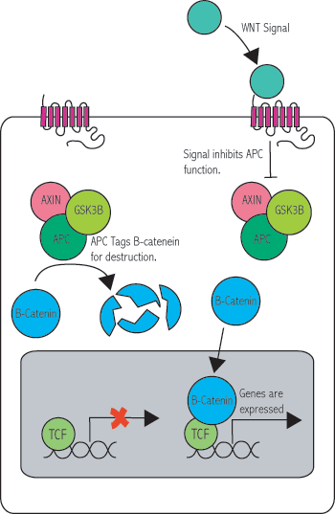
Figure 1. The Canonical Wnt Pathway
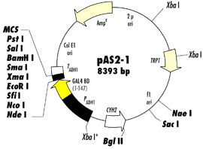
Figure 2. Restriction Map and Multiple Cloning Site of pAS2-1

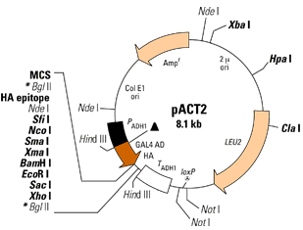
Figure 3. Restriction Map and Multiple Cloning Site of pACT2

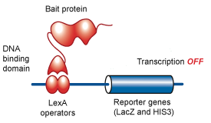
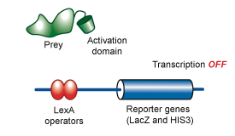
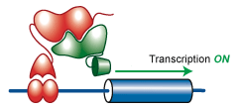
Figure 4. Schematic Diagram of the Yeast Two-Hybrid System

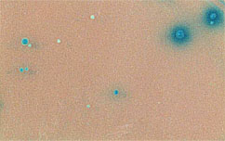
Figure 5. The Representative Result of Yeast Two-Hybrid Assay

